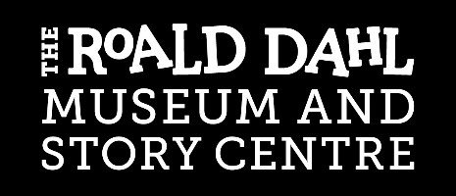
The Amanda Conquy Travel Bursary

Application Form

The Roald Dahl Museum and Story Centre is able to offer a travel bursary for up to 10 schools each year. It is available as full or part payment for travel to and from the Museum up to a maximum of £450. It does not cover the cost of the school visit; this fee is still applicable.

The bursary is available for schools that may be deterred from organising a visit due to the cost of transport and whose students would most benefit from a visit to the Museum. You should write a clear statement outlining why your school needs the award and how the bursary will make a difference for your pupils.

You should explain relevant factors such as:
- Numbers in your school receiving free school meals
- If your visit makes use of your Pupil Premium allowance
- Percentage of EAL students
- Barriers to your visit
- The impact that you expect your visit to have

School Details
Name of the school

Address

Telephone Number

Email address

Has your school received a travel bursary from us in the past? Yes No

If ‘yes’, when?

Please note, we may give priority to schools for whom this is the first travel bursary application.

Details of visit to be made
Date/s of visit (please contact us to provisionally book your visit before making this application)

Number of pupils involved

Estimated costs (please ensure you seek the best value available)
Travel cost

Method of travel and company used

Amount you would like to apply for (maximum £450 per school)

To support your application please write a detailed description of how your students would benefit from a Museum visit.

Signature of applicant ____________________________________ Date _____________

Name and position held at the school ________________________________________________

Thank you for taking your time to fill out this application

