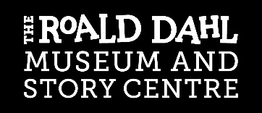
Application for the role of Trustee,
Board of the Roald Dahl Museum and Story Centre

CONFIDENTIAL

Please tell us if there is anything you need to be able to apply or attend an interview.

Title: | Surname: | First Name(s) & Preferred Pronouns:
Home Address: |  | Contact Number:
 |  | Email Address:
 |  | Current Occupation:
Please tell us why you are interested in becoming a Trustee at the Roald Dahl Museum and Story Centre.

Please tell us what skills and professional or personal experience you could bring to the Board and Museum.
NB For the 2026 trustee recruitment, we are specifically looking for candidates who have expertise in Human Resources, Fundraising, Finance or Partnerships.

Please tell us what you hope to learn or gain through being a Trustee on the Board of the Roald Dahl Museum and Story Centre.

Is there anything else you would like to tell us about your application to be a Trustee?
(e.g. if you have any access requirements, uncertainty regarding your eligibility, or any questions we might be able to answer before an interview)

Referees
Please give the names and contact details of two referees (who should not be related to you) who can vouch for you as a suitable candidate to govern a charity that works with children and young people, and for the reliability of information provided in this form.
We will only approach referees if we offer you the role.

First referee  Name:  Relationship to you:  Telephone:  Email: | Second referee  Name:  Relationship to you:  Telephone:  Email:

Please return this form to:

Trustee Recruitment
The Roald Dahl Museum and Story Centre
81-83 High Street
Great Missenden
Bucks, HP16 0AL

Tel: 01494 892192
Email: hello@roalddahlmuseum.org

Please complete the application form and send with your current CV or a link to your LinkedIn Profile.

